POLIO AWARENESS SEMINAR - 2012
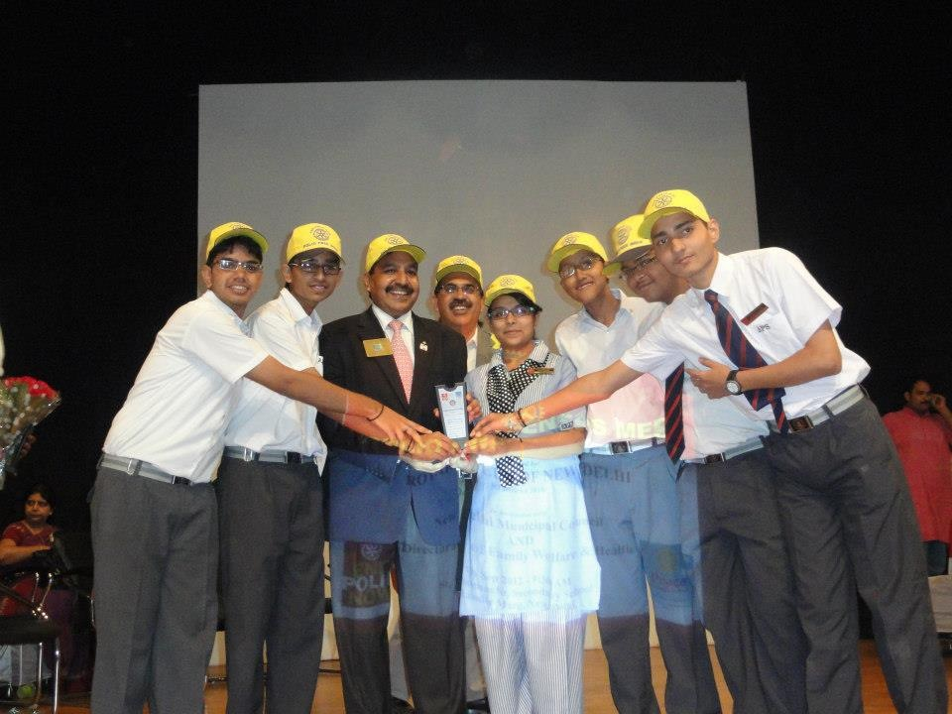
The members of the Interact Club attended a Polio Awareness Seminar organised by the Rotary Club New Delhi at St Thomas School, Mandir Marg on Friday, 7th September 2012. The students were also part of a Polio Rally along with other 600 students from various school like Maharaja Agarsain Public School, NM School, Saraswati Vidyalaya, St Thomas, etc. The students won an award from Rotary Distt Governor Ramesh Aggarwal for their stage presentation on Polio.

