VOLLEYBALL MATCH
WITH
AMERICAN EMBASSY SCHOOL
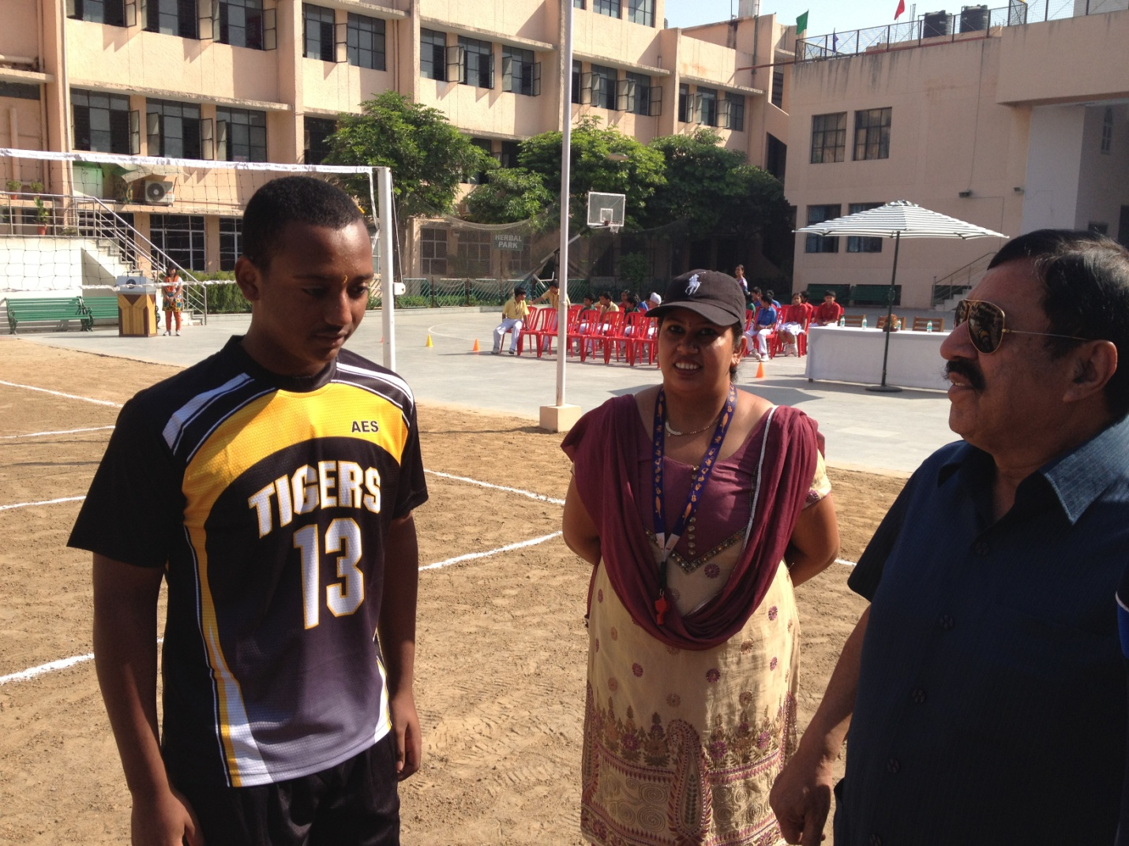

The school hosted the senior Boys Volleyball Team of the American Embassy School, Chanakya Puri at our school grounds on Saturday, 6th October 2012. The teams played 3 games which the home team won hands down. The school will play a reciprocal match at the Embassy School on Friday, 11th October 2012.

